**ABOUT US**

**A MODERN FAMILY BUSINESS WITH**

**3 GENERATIONS OF EXPERTISE IN**

**SERVICE, SUPPLY AND SOURCING**

**FOR INDUSTRY**

We are a modern, forward looking family business with 3 generations of

Expertise in service, supply and sourcing for the industry. We help companies to

Manage, buy and source industrial supplies and tools. We are passionate

bout what we do and the impact that our work has on our team, customers,

suppliers and the world around us. We work hard to develop and maintain

longstanding relationships based on growth, thrust, honesty and sustainability.

We’re a British company based in Burton Upon Trent. We have Offices, Warehouse and Trade Counter serving industrial companies with Staffordshire, Derbyshire and Beyond.

We are a family business guided by strong ethical principles and shared values. We recruit our team, customers and suppliers to the values expressed in our 4 agreements.

We support our customers to learn to buy effectively through training, supply reviews and buying guides.

Our team are knowledgeable and experienced. We are also committed to ongoing training so that we can help you to get what you need.

We are an award-winning company named by the THS National Tool Buying Group as member of the year.

We believe that buying industrial tools and supplies should be easy and enjoyable. If it isn’t easy for you – Let us source, it for you!

**3 GENERATIONS – THE STORY SO FAR**

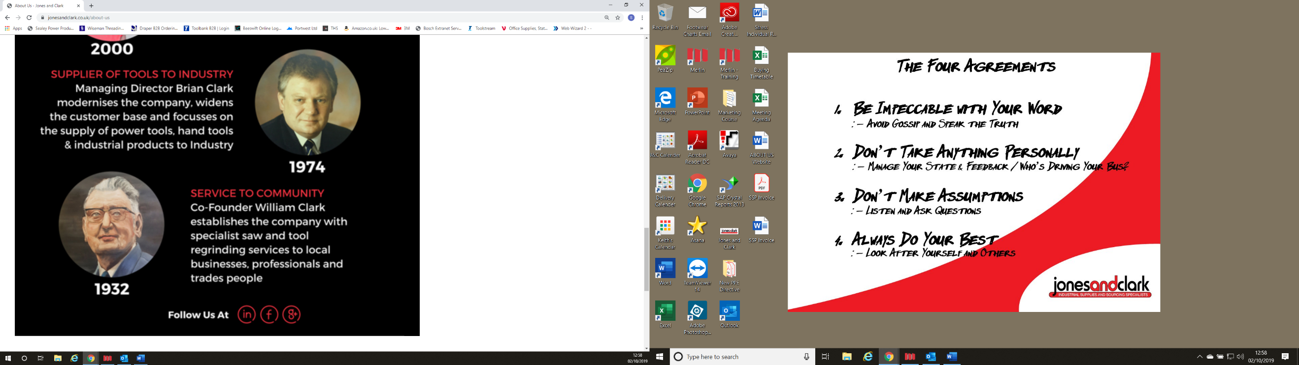

1932 – SERVICE TO THE COMMUNITY

Co-Founder William Clark establishes the company with specialist saw and tool regrinding services to local businesses, professionals and trades people.

1974 -SUPPLIER OF TOOLS TO INDUSTRY

Managing Director Brian Clark modernises the company, widens the customer base and focusses on the supply of Hand Tools, Power Tools and Industrial products to the industry.

2000 - SOURCING & SUPPLY SPECIALISTS

Managing Director Simon Douglas-Clark & Creative Director Monica Douglas-Clark expand Jones and Clark by moving to a larger premises, updating the company’s technology and adding Sourcing Services to our already impressive catalogue of services and supply.

2019 - STOCK MANAGEMENT EXPERTS

Current Director Simon Douglas-Clark leads the next growth phase of Jones and Clark as experts in Stock Management Systems for industry.